## CSE100 Fundamentals of Computer Programming

## Project Design Document

## Group-10

## Section-3

**Team Member 1 :**

Enrolment No. - AU2140161

Name - Mihir Kotecha

Programme - B-Tech CSE (Section-3)

**Team Member 2 :**

Enrolment No. - AU2140162

Name - Krutarth Vora

Programme - B-Tech CSE (Section-3)

**Team Member 3 :**

Enrolment No. - AU2140166

Name - Nisarg Patel

Programme - B-Tech CSE (Section-3)

* User Interface Design :
* Design of Authentication Phase as different Roles

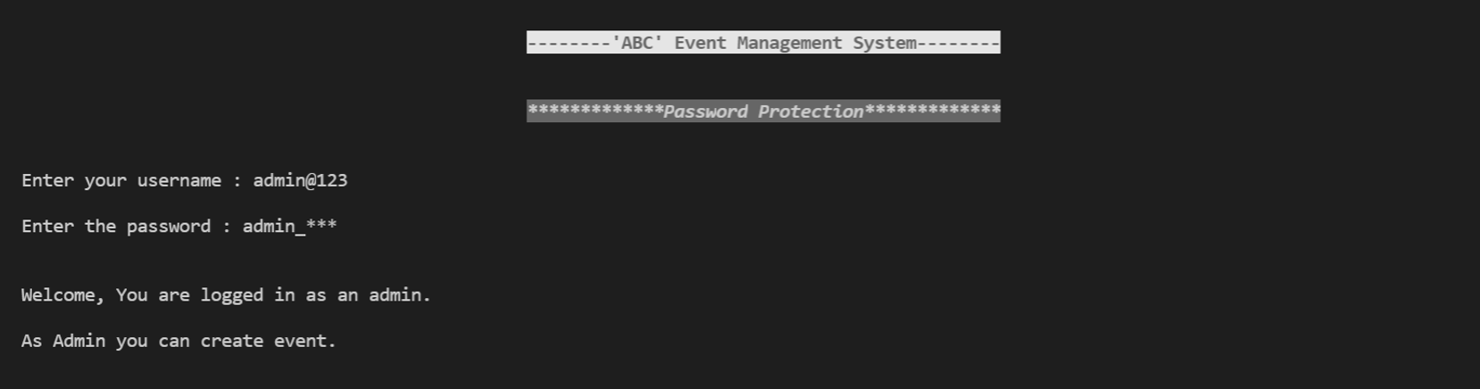**(1)** **Admin :**

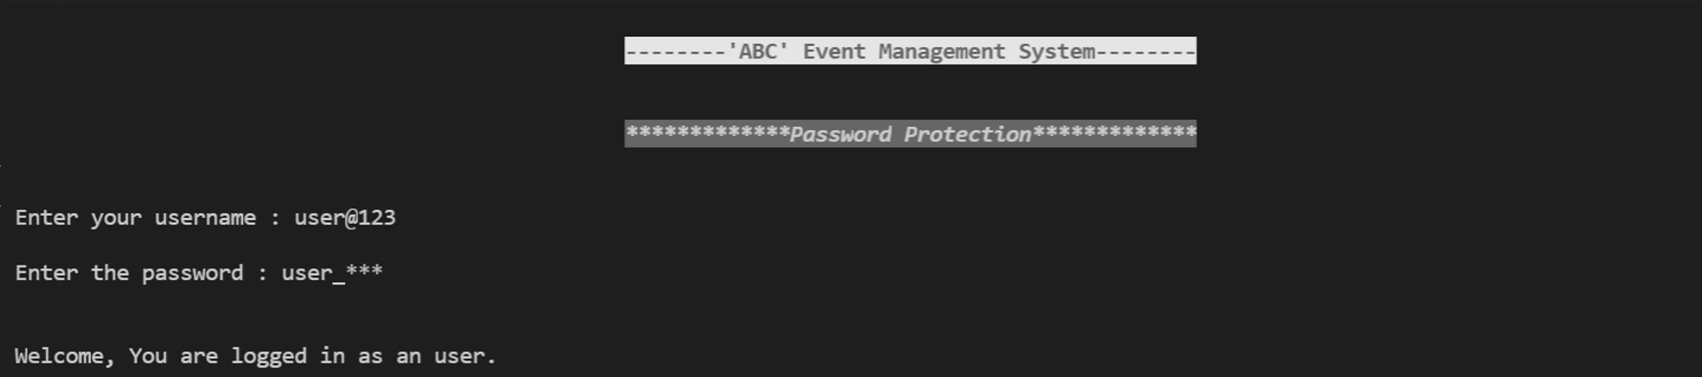**(2) User :**

* 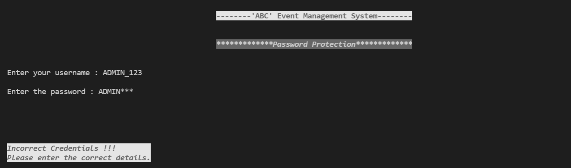**Invalid Credentials :**
* **Main Menu for Admin Role** :

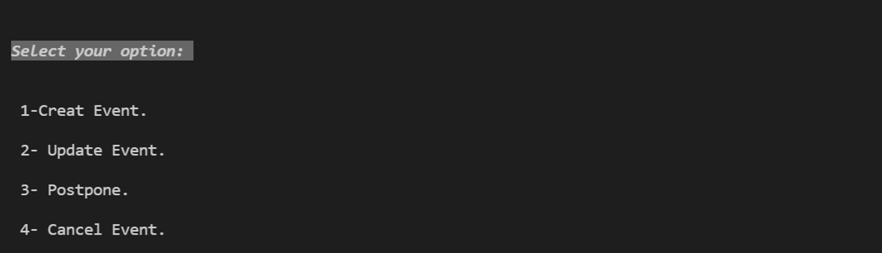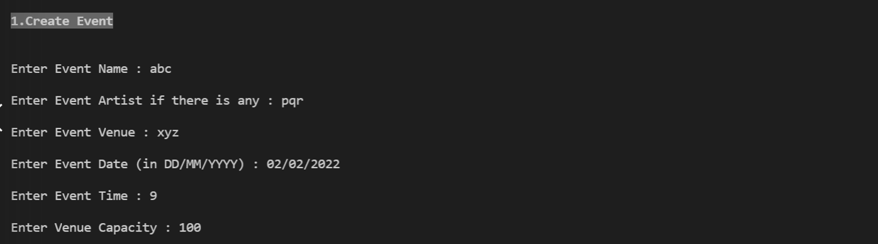

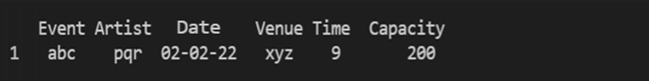

* **Structure Chart :**

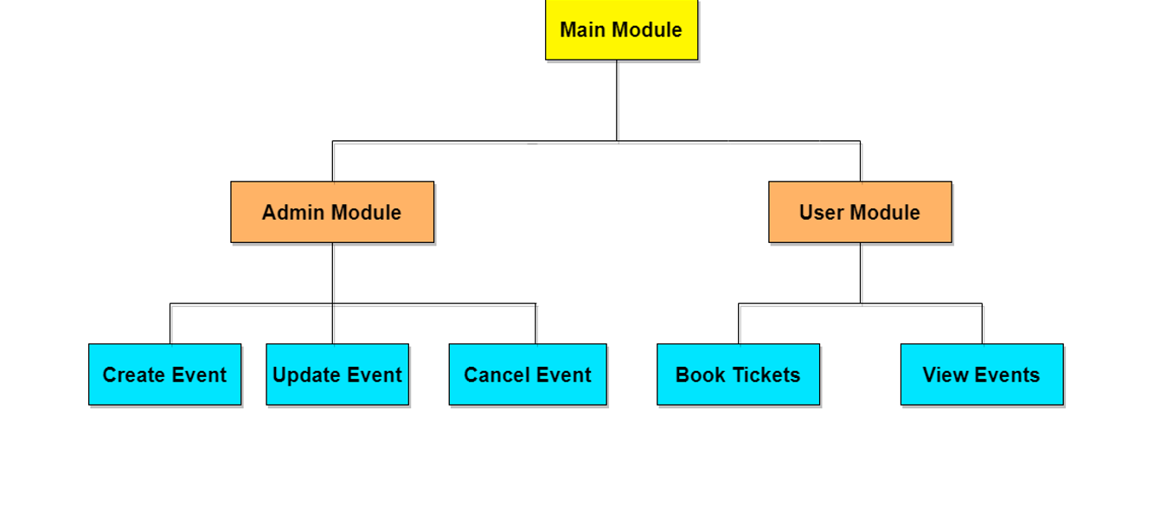

* **Algorithm for Admin Module** :

**Step-1** Start with welcome screen.

**Step-2** Authenticate user as per user’s role. (Admin/User)

If credentials are correct and they are of Admin;

Yes- Then go to step-3,

No – Validation for Incorrect credentials.

**Step-3** Display menu for admin user.

1. Create Event
2. Update Event
3. Cancel Event

**Step-4** Get admin choice

**Step-5** If choice == 1, then go to step-6

**Step-6** Create an object for event class

Call the class method for getting event details

**Step-7** User input for event details

1. Event Name
2. Event Artist
3. Event Venue
4. Event Date
5. Event Time
6. Event Capacity

**Step-8** Call method to save event details.

**Step-9** Stop